Shrinkage correlation: NZDUSD and USDJPY
Method 08 / eight-major panel / delta = 0.2 and Ledoit-Wolf / Alpari D1 full available history

Study setup
Logical pair: NZDUSD , USDJPY
Broker symbols: NZDUSD_i , USDJPY_i
Snapshot: 2026-11-03_majors_alpari_D1
Timeframe: D1
Common eight-major panel window: 1999-01-06 to 2026-11-02 (UTC bar dates)
Panel matched return count n: 7127
Dropped unfinished last bar dated 2026-11-03 UTC after a tick-volume check against the prior complete day.
Fixed shrinkage: delta=0.2, mu=3.9170889e-05 (mean of diag(S))
Ledoit-Wolf estimated delta: 0.0042157642
Panel symbols: EURUSD, GBPUSD, AUDUSD, NZDUSD, USDJPY, USDCHF, USDCAD, EURGBP
Complete matched rows (Excel): NZDUSD-USDJPY_Shrinkage_D1.xlsx
Complete matched rows (HTML table): NZDUSD-USDJPY_Shrinkage_D1_data.html

Method carried forward
Shrinkage blends the sample covariance matrix S of matched daily log returns of close, ln(close_t / close_t-1), toward a simple target, then converts the shrunk covariance into correlations. Quotes are not inverted. This experiment builds one common calendar across all eight majors, forms S with the unbiased n-1 divisor, then reports two shrinkage specs: fixed delta = 0.2 with mu equal to the average sample variance (mu * I target), and sklearn Ledoit-Wolf with its estimated delta. Pair reports pull rho_ij from those panel matrices. Same-panel Pearson r is a side check only. Shrinkage improves conditioning; it is not a cause, not a lead, and not a trading signal.

Results
pearson_r | rho_02 | rho_LW | rho_02_minus_r | rho_LW_minus_r | delta_LW
-0.133871 | -0.110653 | -0.133395 | 0.023218 | 0.000476 | 0.00421576

Conclusion
Over the common 7127-day eight-major panel for NZDUSD and USDJPY (broker quote directions unchanged), fixed-delta shrinkage correlation at delta=0.2 is -0.1107 (negative, weak linear link in this sample). Ledoit-Wolf rho is -0.1334 with estimated delta=0.004216. Same-panel Pearson r is -0.1339 (rho_02 minus r = 0.0232; rho_LW minus r = 0.0005). This does not establish cause, lead-lag, or a lasting trading rule.

Charts
Daily closes
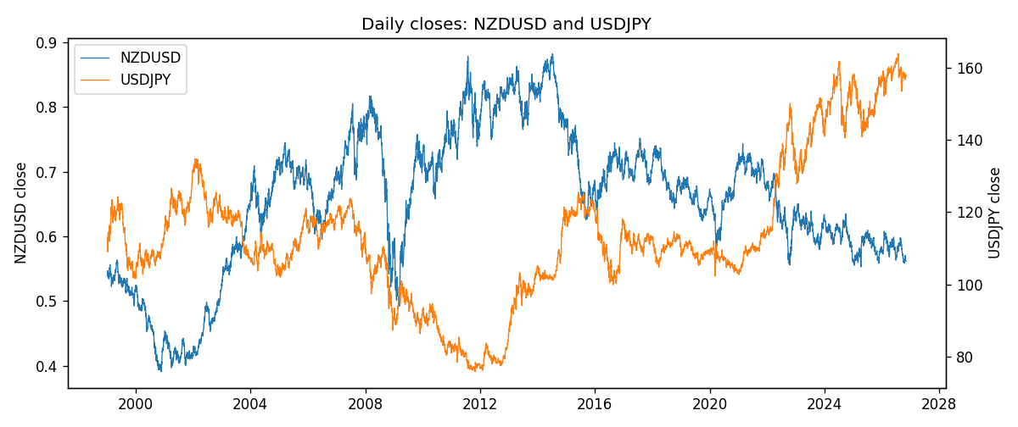
Daily log returns
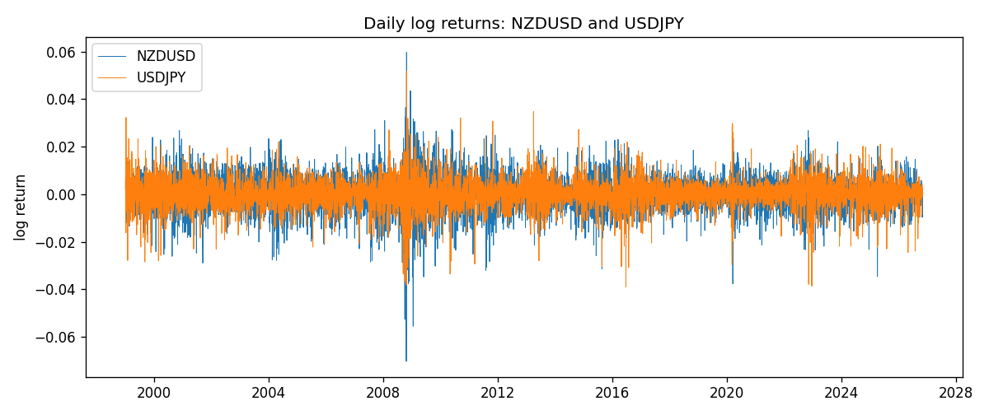
Log-return scatter
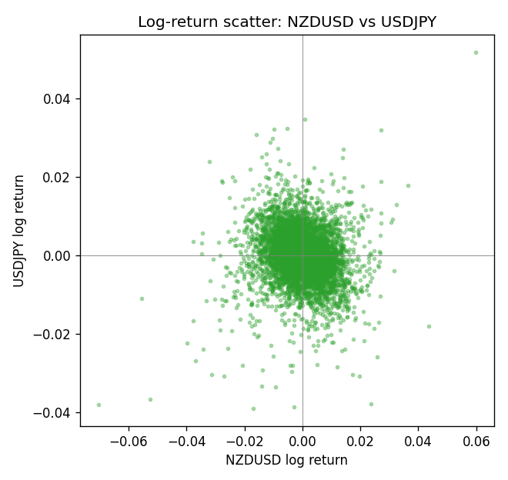

Data report
Every panel row for this pair slice is stored in the sibling Excel workbook named NZDUSD-USDJPY_Shrinkage_D1.xlsx. Full-panel covariance and correlation matrices are saved once under outputs/ as CSV files. Embedding all rows as a Word table is impractical at this length; the Word file holds the column list, column summaries, and the first and last 15 matched rows.
Columns: time, NZDUSD_open, NZDUSD_high, NZDUSD_low, NZDUSD_close, NZDUSD_tick_volume, NZDUSD_spread, NZDUSD_real_volume, NZDUSD_log_return, USDJPY_open, USDJPY_high, USDJPY_low, USDJPY_close, USDJPY_tick_volume, USDJPY_spread, USDJPY_real_volume, USDJPY_log_return
Column summaries (panel rows)
column | count | mean | std | min | 25% | 50% | 75% | max
NZDUSD_open | 7127 | 0.65707489 | 0.10792246 | 0.3913 | 0.59224 | 0.66889 | 0.725215 | 0.88218
NZDUSD_high | 7127 | 0.66100044 | 0.10841069 | 0.3961 | 0.595625 | 0.6726 | 0.72964 | 0.88421
NZDUSD_low | 7127 | 0.65338952 | 0.10751648 | 0.3897 | 0.588615 | 0.6651 | 0.721335 | 0.87988
NZDUSD_close | 7127 | 0.65715675 | 0.10791625 | 0.3907 | 0.5923 | 0.66906 | 0.725335 | 0.8822
NZDUSD_tick_volume | 7127 | 69244.396 | 123501.01 | 17 | 5842 | 34224 | 58735 | 1127682
NZDUSD_spread | 7127 | 30.023572 | 25.540824 | 0 | 9 | 17 | 40 | 80
NZDUSD_real_volume | 7127 | 1.6834718e+10 | 8.5315436e+10 | 0 | 0 | 0 | 0 | 2.705649e+12
NZDUSD_log_return | 7127 | 2.447e-05 | 0.00764665 | -0.07027433 | -0.00423198 | 0.00024001 | 0.00459119 | 0.05966839
USDJPY_open | 7127 | 113.80058 | 19.291864 | 75.693 | 104.3005 | 110.961 | 120.7475 | 163.824
USDJPY_high | 7127 | 114.29785 | 19.353625 | 76.001 | 104.822 | 111.42 | 121.29 | 163.978
USDJPY_low | 7127 | 113.2782 | 19.219415 | 75.402 | 103.814 | 110.515 | 120.2 | 163.628
USDJPY_close | 7127 | 113.81424 | 19.307121 | 75.811 | 104.298 | 110.98 | 120.725 | 163.851
USDJPY_tick_volume | 7127 | 107141.8 | 179947.68 | 197 | 10056 | 53577 | 93233 | 1803508
USDJPY_spread | 7127 | 20.095973 | 17.5534 | 0 | 6 | 11 | 30 | 50
USDJPY_real_volume | 7127 | 3.5056645e+10 | 1.6155964e+11 | 0 | 0 | 0 | 0 | 3.8834203e+12
USDJPY_log_return | 7127 | 5.336e-05 | 0.00621278 | -0.03908203 | -0.00319557 | 0.00013026 | 0.00340928 | 0.05184024
First 15 panel rows (selected columns)
time | NZDUSD_close | USDJPY_close | NZDUSD_log_return | USDJPY_log_return
1999-01-06 | 0.5383 | 112.77 | 0.0020455609 | 0.0075660159
1999-01-07 | 0.5417 | 111.33 | 0.0062963171 | -0.012851583
1999-01-08 | 0.5414 | 110.8 | -0.00055396548 | -0.0047719894
1999-01-11 | 0.547 | 109.02 | 0.010290425 | -0.016195423
1999-01-12 | 0.5441 | 112.6 | -0.0053157489 | 0.032310364
1999-01-13 | 0.5387 | 113.52 | -0.0099742238 | 0.0081373171
1999-01-14 | 0.5386 | 113.52 | -0.00018564931 | 0
1999-01-15 | 0.5382 | 114.15 | -0.00074294208 | 0.0055343401
1999-01-18 | 0.5372 | 114.16 | -0.0018597736 | 8.7600193e-05
1999-01-19 | 0.5382 | 113.52 | 0.0018597736 | -0.0056219403
1999-01-20 | 0.5404 | 112.91 | 0.0040793678 | -0.0053879917
1999-01-21 | 0.5426 | 113.87 | 0.0040627941 | 0.0084664056
1999-01-22 | 0.5361 | 114.56 | -0.012051689 | 0.0060412564
1999-01-25 | 0.5342 | 113.72 | -0.0035504102 | -0.0073594164
1999-01-26 | 0.5381 | 113.86 | 0.0072741158 | 0.0012303367
Last 15 panel rows (selected columns)
time | NZDUSD_close | USDJPY_close | NZDUSD_log_return | USDJPY_log_return
2026-10-13 | 0.56127 | 158.305 | 0.0047326165 | -0.0018932826
2026-10-14 | 0.55918 | 158.317 | -0.0037306483 | 7.5800166e-05
2026-10-15 | 0.56185 | 158.024 | 0.0047634855 | -0.0018524319
2026-10-16 | 0.56509 | 157.964 | 0.0057501001 | -0.00037976126
2026-10-19 | 0.56616 | 158.517 | 0.0018917133 | 0.0034946841
2026-10-20 | 0.56827 | 158.16 | 0.0037199341 | -0.0022546642
2026-10-21 | 0.57003 | 158.108 | 0.0030923331 | -0.00032883504
2026-10-22 | 0.56815 | 156.755 | -0.0033035227 | -0.0085942669
2026-10-23 | 0.56991 | 156.81 | 0.0030929853 | 0.00035080446
2026-10-26 | 0.56826 | 157.458 | -0.0028993932 | 0.0041238746
2026-10-27 | 0.56811 | 157.894 | -0.00026399852 | 0.0027651658
2026-10-28 | 0.56261 | 157.743 | -0.0097283914 | -0.00095679538
2026-10-29 | 0.56296 | 157.683 | 0.00062190714 | -0.00038043789
2026-10-30 | 0.56307 | 157.516 | 0.00019537668 | -0.0010596481
2026-11-02 | 0.56161 | 157.933 | -0.0025962955 | 0.0026438521

